Using AppLife® Update

Updating Your Software

Updating User Experience Options
The AppLife Update solution provides a choice of options for integrating an updating user experience into your applications. Using the visual controls included with AppLife Update, you can very quickly integrate a complete updating user experience into your applications. Many customizations are available through the properties of the controls.

You can also build your own updating user experience by utilizing the AppLife Update API. See the Custom Forms Quick Start for more information on building a customized user experience.

Windows Forms Visual Controls

UpdateDisplay Control
The UpdateDisplay control is designed to be placed on an application’s main interface, and upon startup, perform a background update check. If an update is present, a download is automatically initiated, with download progress indication. When the download completes, the control notifies the user that an update is ready to be applied.

This control utilizes minimal screen space, displaying a single 16 X 16 icon and a text label. The image and label is configurable by the DisplayMode property. Additionally, the image and text displayed when an update check completes, either with an update available or without, is customizable by setting control properties. Detailed information about the update is available as a pop up, through the control context menu or control click action.
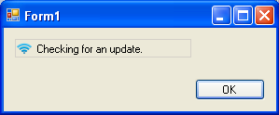
Checking for an update. (Animated image)

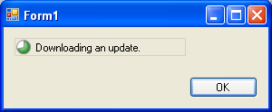
Downloading an update. (Animated with progress)

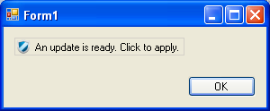
Ready to apply an update. (Customizable text and image)

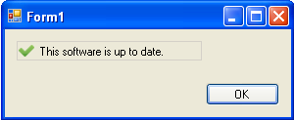
No updates available (Customizable Text and image)

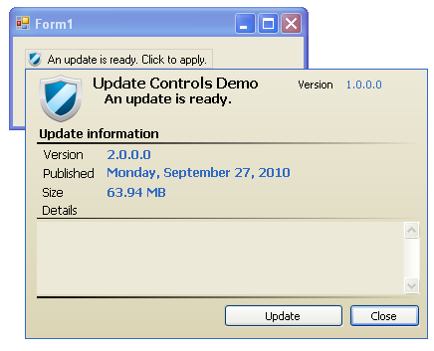
Update details popup.

UpdateNotifyIconDisplay Control
The UpdateNotifyIconDisplay provides an updating experience through the windows system tray. No visual elements are present on the hosting form. This control can be used independently or simultaneously with other update display controls.
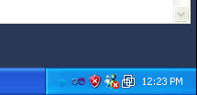
Checking for updates. (Animated image)

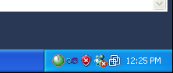
Downloading an update. (Animated with progress)

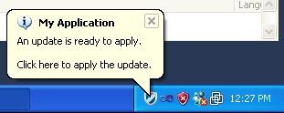
Ready to apply an update (Customizable text and icon).

By default, no image is displayed in the system tray when no updates are available. This can be enabled and customized through the control properties.

UpdateDetailsDisplay Control
The update details display control is designed to provide a drop in details panel onto an existing form.
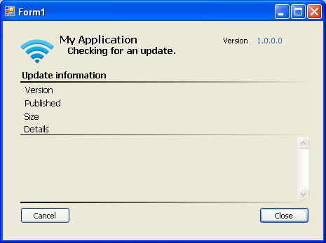
Checking for an update. (Animated image)

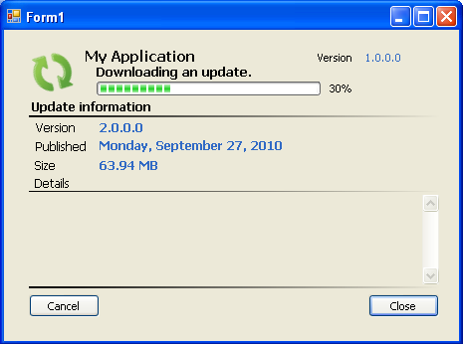
Downloading an update.

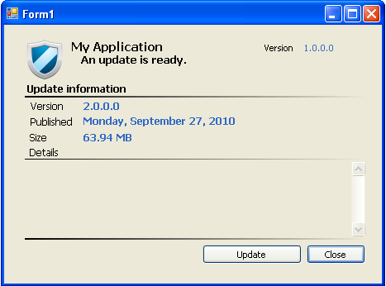
Update is ready (customizable image and text).

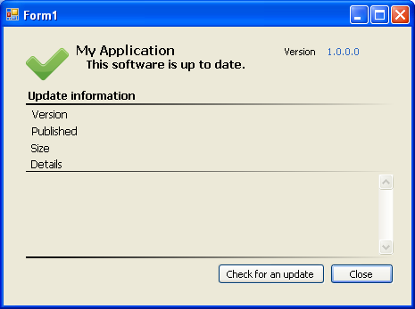
No updates are available (customizable image and text).

StatusStripUpdateDisplay Control
The StatusStripUpdateDisplay control provides an update experience that resides within a Windows Forms StatusStrip.

Note: This control does is not located in the Visual Studio toolbox. You can add it to an existing Status Strip using the Status Strip Control pane drop-down.
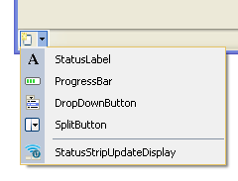

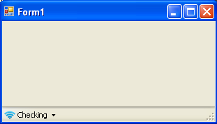
Checking for updates. (Animated image)

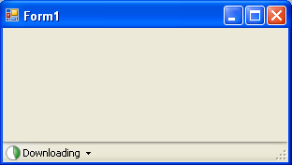
Downloading an update. (Animated progress)

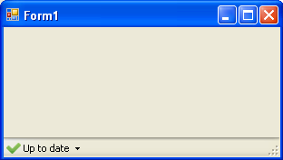
No updates available (customizable image and text).

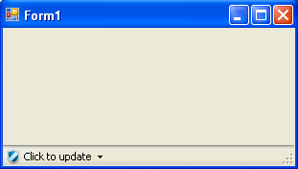
Update is available (Customizable image and text).

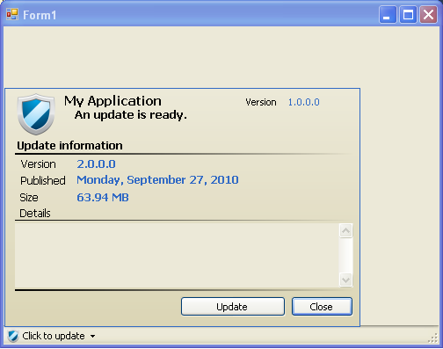
With details pop up open.

Update Interactive
The update interactive user experience provides a dialog based updating experience. The update interactive user experience is launched by calling the UpdateInteractive method of the update controller.
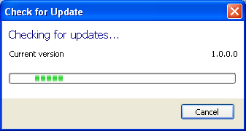

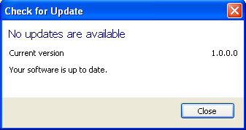

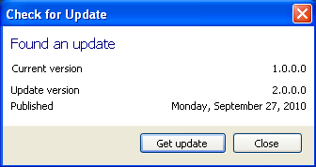

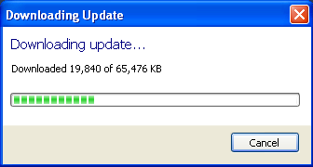

UpdateDisplay WPF Control
The UpdateDisplay WPF control is a true WPF control that provides a user experience identical to the WinForms UpdateDisplay control. Being a WPF control, in addition to the property-based customizations available, the control can be re-templated to provide a customized look and feel. The control template can be copied from the AppLife Update installation directory (InstallDir/themes/generic.xaml).

The UpdateDisplay control is designed to be placed on an application’s main interface, and upon startup, perform a background update check. If an update is present, a download is automatically initiated, with download progress indication. When the download completes, the control notifies the user that an update is ready to be applied.

This control utilizes minimal screen space, displaying a single 16 X 16 icon and a text label. The image and label is configurable by the DisplayMode property. Additionally, the image and text displayed when an update check completes, either with an update available or without, is customizable by setting control properties. Detailed information about the update is available as a pop up, through the control context menu or control click action.

The WPF UpdateDiaplay control can be found in the Visual Studio WPF toolbox.

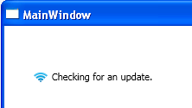
Checking for an update. (Animated image)

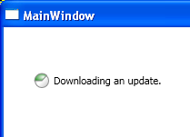
Downloading an update. (Animated with progress)

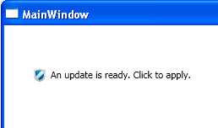
An update is ready (customizable image and text).

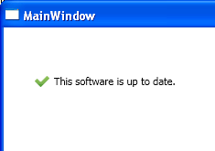
No update is available (customizable image and text).

UpdateDetailsDisplay WPF Control
The update details display control is designed to provide a drop in details panel onto an existing form.
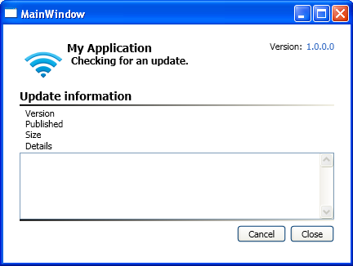
Checking for updates.

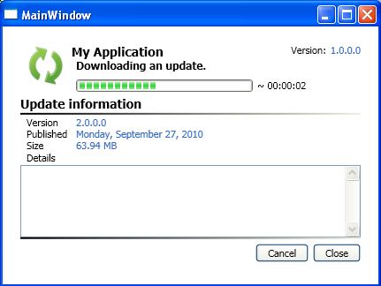
Downloading an update.

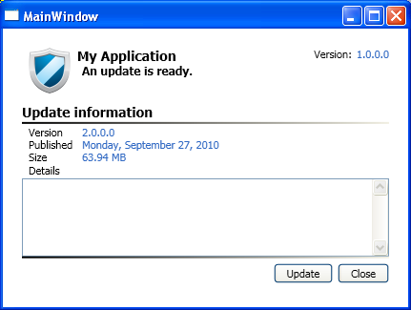
An update is ready (customizable image and text).

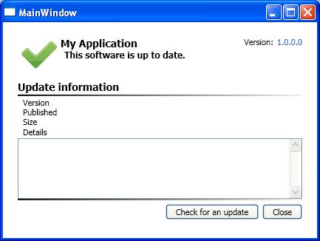
No updates available (customizable image and text).

Visual Control Configuration Options

Auto Start
When auto start is enabled, the control will initiate an update process automatically. By setting the AutoStart property to false, the control will not initiate an update check automatically. When disabled, clicking on the control will initiate an update check, and the StartUpdateCheck method can also be used to programmatically initiate an update check.

Auto Hide (UpdateDisplay)
When the Auto Hide option is enabled, the control will perform the update check and download. When completed, if the user does not interact with the control, its visibility will fade to invisible after the designated period of time (in seconds). To enable, set the AutoHideDelaySeconds property to a non-zero value. The default value is 0.

Recheck Delay
The control can be configured to repeat an update check after a period of time by setting the RecheckDelayMinutes to a non-zero value. The default value is 0. For rechecks to occur, the control must also be configured to Auto Start.

Click Action (UpdateDisplay)
The Click Action option determines the behavior when a user clicks on the control. The options are:
- Update (default) – When the control is clicked and an update is ready to be applied, the update process is initiated.
- Show Details Form – When the control is clicked, the update details pop up is opened.
- None – Clicking on the control performs no action.

Display Mode
The control display mode determines the image and text display of an Update Display control. The options are:
- Image and Long Text (Default)
- Image and Short Text
- Image Only
- Long Text Only
- Short Text Only

When long text is selected, the status of the control shows a more verbose label than when short text is selected.

Application Name
When the application name property is set, it is displayed on the update details, system tray bubble, and tooltips.

No Update Text and Image
When the No Update Text and Image properties are set, these customizations replace the default image and text that the control uses in this update state.

Ready to Apply Text and Image
When the Ready to Apply Text and Image properties are set, these customizations replace the default image and text that the control uses in this update state.

Apply Update Options
The Apply Update Options property lets you configure the options available as an update is initiated.

UpdateReady Event
The UpdateReady event is raised on the controls when an update download is completed.

Show Close Button (UpdateDetailsDisplay)
A close button can be displayed on the Update Details Display by setting the ShowCloseButton to true. The CloseRequested event is raised when the button is clicked.

CloseRequested Event
The CloseRequested event is raised when the close button shown on the control is clicked.

Getting Updates
The process of retrieving an update from a network resource is controlled by the Update Controller. The Update Controller is a component placed in your application. The Update Controller contains three properties that determine how updates are retrieved.

Update Location
The network URI that identifies where to look for updates. This value can be:
- A file path (C:\My Applications\Updates\App1)
- A UNC Path (\\mynetworkserver\Updates\App1)
- An http location (http://mywebserver/Updates/App1)
- An https location (https://mysecureserver/Updates/App1)
- An ftp location (ftp://myftpserver/Updates/App1)

ApplicationID
Every application has a unique guid identifier. The update controller will not attempt to update from an update location with a different Application ID.

Version
The Version property identifies the version of the software requesting an update. Versions are of the form <Major>.<Minor>.<Build>.<Revision>. When updates are published, they can be made available only for specific previous versions, allowing for a great deal of flexibility in software update package management.

When an update check is performed, the Update Controller looks for updates at the specified Update Location that targets the version of the client. The updates at the location must match the application id of the update controller. If there is an update available, information about the update can be displayed to the user. The update can also be downloaded and applied.

Versioning
In order to determine the availability of an update, the current software version must be known. AppLife Update supports two mechanisms for determining the current software version. You can use either the Version property of the Update Controller, or the assembly version of the host executable.

Update Controller Version Property
If you use the Version property of the update controller, you can set the version property programmatically. This version number does not need to match the assembly number of the host application. This versioning scheme is commonly used to enable updating without being required to re-build the application assembly being updated. It is also used when a sub-component of an application is being updated separately from the main application. The UseHostAssemblyVersion property must be set to false in order to use this versioning technique.

Host Assembly Version
The current client version can be determined by reading the .Net Assembly Version of the host application. This value is set by the .Net framework [assembly: AssemblyVersion] attribute. To use the host assembly version, set the Update Controller UseHostAssemblyVersion property to true. When using the host assembly version, the Update Controller Version property is ignored.

Synchronizing the Update package version with a file
To automatically set the update version while building new updates, you can link the update version of newly created update packages to a file on your build system. When linked, the update version of new updates is automatically assigned to the assembly version or file version of the designated local file.

Director
The Director file is created upon first publishing an update, and maintained as each additional update is published. The file contains information about each update and is used to determine update availability and provide information about the updates. Each update location contains a Director file.

Check for Update
Methods on the Update Controller are used to Check for Update. When checking for an update, the Director file is downloaded and analyzed by the Update Controller to discover any available updates that target the current application version. If there is an update available, the information about that update is presented.

Intervening during a Check for Updates
Through the UpdateFound event of the Update Controller, implementers can intervene when an update is discovered. This might be necessary to check licensing or validate a specific client’s eligibility to receive an update. From within this event handler, an implementer can allow the update, cancel the update, or even choose from a list of the possible earlier updates for the specific target being updated.

Custom Data
For each update, a publisher can set a Custom Data text property. This property is available to you during a Check for Update operation and can be used for special custom processing or decision making. Kinetic Jump does not use this property for any actions and you can freely use it to customize your update discovery process.

Downloading
When an update is found to be available, the update package is downloaded and placed into a temp folder. As the file is being downloaded progress indication is provided to the user. A download can be canceled by the user.

Cached Downloads
An update package is cached as it is being downloaded. When the download is complete, it is available to be applied. If an update was previously downloaded and cached without being applied, the update can be applied without asking the Update Controller to download the update package again. From the Update Controller’s CurrentUpdate property, an integrator can identify whether the current update is already downloaded by referring to the IsDownloaded property.

Resuming a Failed Download
Downloaded update packages are cached to disk during the download process. If your network connection is lost during an update download, the next download attempt will resume from where the previous download failed. If an update download was completed, but not applied, the update package will be persisted and ready for the next update attempt.

To specify a preferred folder to download update packages, you can set the PreferredDownloadPath property of the Update Controller prior to downloading the update. You must ensure that the designated folder exists and that the user performing the update has permissions to write to the preferred directory.

Download Authentication
Server credentials can be set on the AppLife Update Controller that allows the controller to download updates from server locations that do not allow anonymous access.

Download Verification
Upon successful download of a discovered update, the downloaded file is verified to be intact and that it came from the same publisher that supplied the application being updated. This is accomplished using the RSA Crypto Service Provider Sign Data functionality. When a new Update Project (aup) is created using the Make Update application, an RSA public-private key pair is created. The private key is used to sign the update package after it is built. The public key is placed in the PublicKey property of the Update Controller.
When a new update package is created, the resulting file is signed using the RSA Crypto Provider and the private key of the update project. The signature of the package is placed in the Director file to be provided to the application while downloading an update.
When the hosted application downloads the update package, the signature and public key are used to verify that the downloaded file has not been changed, and that it came from a source that had the proper private key. If any changes were made to the file, or if the update package had been created without the appropriate private key, the verification will fail and the update package is discarded.
Note: This verification process assumes the sanctity of the private key. If a private key is compromised, AppLife Update would not be able ensure the update package file originated with the original software publisher.

Proxy Servers
Many networks today use proxy servers to control internet access. On these networks, a client application looking for the Uri identified by the UpdateLocation property of the Update Controller might have to navigate first to a proxy server. The application must know the network location of the proxy server for this to occur. The AppLife Update Controller supports automatic proxy detection as well as manual proxy settings.
By default, Automatic Proxy detection is enabled. To set manual proxy information, properties must be set on the Update Controller. A user interface to allow a user to interact with these settings, and a persistence mechanism are not provided by AppLife Update. Implementers needing this functionality must provide this within the hosting application.

Update Controller Proxy Properties
AutoDetectProxy (true by default)
Proxy Address
Proxy Domain
ProxyUseDefaultCredentials
ProxyUserName
ProxyPassword
Proxy Domain
BypassProxyOnLocal

Automatic Update Chaining
Updates chains are made when the current version must first apply one or more updates before the highest available update can be applied. This commonly occurs when dated application installers are used to install your application, or when your application is infrequently used.
The default behavior of AppLife Update would result in the intermediate update versions being discovered and applied individually. You can enable automatic chaining. When automatic chaining is enabled, all available updates are downloaded in a single process, and each update is sequentially applied before your application is restarted as the highest available version.
To enable automatic chaining, set the EnableAutoChaining property of the Update Controller in your application to true.
Non-Chainable Updates
If you publish an update that would not participate properly within a chain of updates, you can designate that update as non-chainable. An update that requires the operating system to restart, or that might rely on activity that your application performs as it is restarted are examples of non-chainable updates. To designate an update as non-chainable, clear the Allow chaining from this update checkbox as your update is created. This value can be modified after the update is built by managing published updates.

Localized Update Process
The AppLife Update Controller contains built-in forms that allow an implementer to quickly implement a complete update process. This includes a form to check for updates, a form to download an update, and an error status form. The Update Interactive method of the Update Controller uses these forms. You can also use each of the forms individually.

The built-in update forms are localized to the following cultures:
- English (en-us) – default
- Chinese – Traditional (zh-CHT)
- French (fr)
- German (de)
- Italian (it)
- Japanese (ja)
- Spanish (es)

When AppLife Update enabled applications utilize the built-in user interface forms, the forms are localized for clients with these Windows versions.

Implementers that do not desire these localizations can remove the culture specific folders containing the localized resources from their application directory.

Customers who would like these user interface forms localized to their culture and are willing to perform the string translations can find information about this process at http://www.kineticjump.com/update/localization.aspx

Executing Updates
Updates are discovered, downloaded and verified to be intact and from the original publisher. Only then can an update be executed. To execute an update package, the Update Controller component initiates the process by communicating with all instances of the hosting application and requesting a shutdown. Implementers can handle the UpdateStarted event of the Update Controller to perform any necessary actions prior to shutdown, such as prompting to save work. The update can also be cancelled from that event. Once the instances have been shutdown, the initiating instance extracts and executes an Update Launcher.
The Update Launcher initiates the update process and then waits until the updating executable completes its work. After the update is complete, the hosting application is launched in its updated state.
The executable that actually performs the update is determined by the Make Update project. It can be either a Microsoft Installer file, a custom created executable, or it can be an AppLife Update Action List executable. The best method to use is dependent on the type of application being updated and the preferences of the developers.

Supported .Net Frameworks
AppLife Update can successfully update .Net applications that target the .Net Framework 2.0 or higher. AppLife Update fully supports the .Net 4.0 framework.

Preserving Command Line Arguments
When the host application is re-launched after an update is executed, you can choose to include the original command line arguments that were passed to the pre-update session. To do so, set the Update Controller property AutoCopyCommandLine to true. The default value is false.

Microsoft Installer Patch
If your organization uses an install creation program such as InstallShield or Wise, you might already be creating Microsoft Installer major upgrades, minor upgrades and patch files for your software. If this is the case, you can utilize the Execute Msi update action to launch your upgrade or patch during an update. You can define the exact command line parameters to pass into the msiexec.exe. When the package is downloaded, verified and executed, your patch will be automatically executed on the client computer.
Note: Microsoft Install Patches cannot be created directly within a Visual Studio Setup Project. You can create an installer patch using the Microsoft Installer SDK. More information can be found at http://msdn2.microsoft.com/en-us/library/aa372866.aspx

Custom Update Executable
If your organization utilizes a custom executable to update your software, or your application requires very unique procedures in order to be updated, you can utilize AppLife Update to manage and distribute these updates. You can apply your custom patch using a Run Command Line Update Action during an update.
Note: Custom Actions within an AppLife Update action list might be a better alternative to the custom executable.

AppLife Update Project
The AppLife Make Update application can be used to define a list of actions that are to be executed on a client computer in order to update your software from one version to another. Actions such as replacing files, modifying registry keys, and registering COM components can be configured in a sequential manner to update your software. These actions are designed to address the most common update steps required for .Net applications. In addition each action is architected to ensure a complete rollback should any update action fail. This prevents the client software from being placed in a comprised condition. If the built in actions are not sufficient to update your software, you can easily create custom actions using any .Net language. Your actions can then be added the list of actions to be executed when your software is updated.

AppLife Update Engine Options
When using an AppLife Update Action List Project, your updates are executed on client systems by the AppLife Update Engine. The operation of the AppLife Update Engine user is configurable within the host application code.

Configuration options for the AppLife Update Engine user interface include:

No User Interface
You can choose not to show this form at all during an update. This options allows you to silently update your application.

Immediate Close
By default, the AppLife Update Engine user interface shows an “update complete” message and requires the user to click a close button to complete the update. Upon clicking the close button, the newly updated application restarts. You can choose not to require the user to click a close button and have the update user interface immediately close upon completion of applying the update.

No Restart
You can configure the AppLife Update Engine interface to not restart the application upon completion of the update.

No Shutdown
By default, when an update is applied, the application hosting the Update Controller is shutdown so that its assembly can be replaced during the update process. In some implementations, this is not desired. You can configure your update process to not shutdown the hosting application during an update process.

These options can be combined for custom configurations. The ApplyUpdate and the UpdateInteractive methods of the Update Controller provide overrides that allow you to configure these options.

Coordinated Application Shutdown
When an update is applied, inter-process communication takes place between all running processes with an instantiated Update Controller. When an update is executed, an attempt is made to shutdown any process with an Update Controller configured with the same ApplicationID as the initiating controller. In each of these processes, the UpdateStarted event is first raised to allow the implementer to perform any necessary work prior to the shutdown attempt. From this event the implementer can control the behavior of the update process.

- Inspect the physical path of the instantiating host assembly, and use this information to support independent side-by-side application updating.
- Cancel the update process currently in progress.
- Ignore the update process, and prevent the current instance from being shutdown, without canceling the entire update process.
- Pass from the initiating application instance to all other instances custom data that can be used to determine the proper behavior to take. Set the UpdateController.CustomIpcData property and investigate the UpdateStarted Event Arguments custom data property.

Note: When the application update process is configured for No Shutdown by using the ApplyUpdateOptions.NoShutdown parameter, only the initiating update process will not shutdown. The inter-process communication still occurs and the UpdateStarted event is raised on all other instances. If your implementation should prevent other processes from shutting down, handle the UpdateStarted event and set up your desired behavior.
Disabling IPC
Update Controller Inter-Process Communications can be disabled by setting the Update Controller DisableControllerIPC property to true.

Passing in Shared Properties for an Update
Shared Properties can be defined within the host application and passed into the update process as the update is initiated. This allows you to pass client-specific information into the update process and use this information to control the behaviors of update actions. Shared Properties can be used as part of Update Action conditional expressions as well as within dynamic actions and custom actions. For more information, reference the AppLife Update API documentation from the Help menu.

Implementing a Custom Update Engine User Interface (IUpdateUI)
The user interface that is displayed to the user while an update is being applied can be customized to match the visual appearance of your application. For customers that would like to add more in-depth visual customizations than are possible through the Project Properties options (adorn a logo image and modify the window title), the standard user interface can be completely replaced with your own customized UI by implementing the Kjs.AppLife.Update.Engine.Core.IUpdateUI interface.

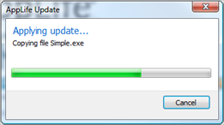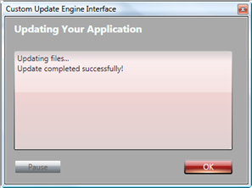
(Left Image – Default User Interface, Right Image – Example Customized User Interface)

To replace the Update Engine UI, you will create a new .Net assembly (.dll or .exe), reference the AppLife Update Core assembly and include one class that implements the IUpdateUI interface. This class will be called by the Update Engine, and should display and update the user interface as the interface methods are called by the AppLife Update engine.
The assembly can then be imported into your AppLife Update project, after which all future update packages built by the project will include the new customized user interface.

IUpdateUI Operations
- As the update engine starts, the IUpdateUI.Open() method is called. In this method you should create and show your customized user interface. Your user interface should remain visible until the IUpdateUI.Finish method is called.
- As the update progresses, the IUpdateUI.Update() method is repeatedly called. This method has parameters that provide information about the current state and progress of the executing update. This information can be used to provide visual feedback within your customized user interface.
- When the update is finished, the IUpdateUI.Finish() method is called. This method has parameters that indicate the condition of the update. If an error occurs during the update, error information is provided through the error parameter. The customized user interface can be safely closed anytime after this method is called, but should not be closed before this method call.
- If the ApplyUpdateOptions.AutoClose option is set by the host application code that initiated the update process, the IUpdateUI.Close() method is called immediately following the Finish method. If this method is called, it is expected that your custom user interface be immediately closed. Note: If you utilize a System.Windows.Forms.Form class and implement the IUpdateUI interface, this method is already present.
- Some update actions request a Yes/No response from the user. To support this, your customized user interface must implement the IUpdateUI.ShowYesNoPrompt() method.
- As your customized user interface is closed, the update engine is notified by your class raising the IUpdateUI.Closed event. Note: If you utilize a System.Windows.Forms.Form class and implement the IUpdateUI interface, this event is already present and is raised when the form is closed.
- Your custom user interface can optionally support canceling an update, as well as pause and resume features by raising the IUpdateUI.RequestCancel, IUpdateUI.RequestPause, or IUpdateUI.RequestResume events.

A sample implementation of a custom update engine user interface is available within the Custom Forms Quick Start example.
For more information on the Kjs.AppLife.Update.Engine.Core.IUpdateUI interface, reference the <OBJECT id=hhctrl type="application/x-oleobject"
classid="clsid:adb880a6-d8ff-11cf-9377-00aa003b7a11"
codebase="hhctrl.ocx#Version=6,0,6001,18000"
width=100
height=100
>
<PARAM name="Command" value="ShortCut">
<PARAM name="Button" value="Text:AppLife Update API Reference">
<PARAM name="Item1" value=",..\API Help\Kjs.AppLife.Update.API.chm,">
</OBJECT>

The First Run after an Update
You can identify the first time your application restarts after an update has been applied by checking the state of the IsFirstRun property of the Update Controller. This value will be true if this is the first start after an update.

Note: Is First Run is user specific. This value should only be relied upon if the user initiating the update will be the user that first restarts the application.

Accessing the Results of the Previous Update
The results of the last update to be applied can be accessed using the ReadLastUpdateInformation method of the Update Controller. This method returns the following information about the last update to be applied:
- Completed Time
The time that the update completed execution
- Error Text
If the last update ended in an error condition, the text of the error can be read.
- Log Path
The path to the action list log file that was created by the update.
- Result
The final result of the update. Success, Failure, Cancellation.
- Starting Version
The software version that initiated the update
- Update Version
The update version that was applied.

Localized Update Engine User Interface
The AppLife Update engine has been localized for the following cultures:
- English (en-us) – default
- Chinese – Traditional (zh-CHT)
- French (fr)
- German (de)
- Italian (it)
- Japanese (ja)
- Spanish (es)

When creating an update project, you can choose one or more languages to provide your update for. You can also supply culture specific release notes for each language selected.

Customers who would like the AppLife Update Engine localized to their culture and are willing to perform the string translations can find information about this process at http://www.kineticjump.com/update/localization.aspx

Elevated Privileges
Depending on the installed structure of your application, it is sometimes necessary for elevated user privileges to accomplish a software update. For example, a standard user cannot replace a file in the Program Files directory. In these circumstances it is necessary to elevate privileges in order to execute an update.
AppLife Update Windows Service
If you are using an AppLife Update action list to update your software, you can elevate privileges by configuring your software to use the AppLife Update Windows Service. This windows service runs under the context of the local system account.
The AppLife Update Service can ONLY be used with an AppLife Update action list. Msi based updates can utilize the elevation features of the Windows Installer. AppLife Update provides no means to elevate privileges during a custom exe update.
To use the AppLife Update Windows Service:
- Configure your application by setting the ElevationType property of your Update Controller to AppLifeUpdateService.
- Add the AppLife Update Windows Service to your application installer. The merge module will install the service and register your application for use. Only registered applications can interact with the service.
When your application distributes the AppLife Update Windows Service and is properly configured to utilize the service, the update engine will execute your update packages under the security context of the Local System. The AppLife Update engine user interface communicates with the service to provide your users progress indication as the service executes your update package.
Applications that utilize the AppLife Update Windows Service will not be prompted by the Windows Vista User Account Control (UAC) when an update is executed.
All of the built-in update actions perform identity impersonation to ensure that any update activity that targets the current user profile will be properly executed by the AppLife Update Windows Service. Custom actions that you create can gain access to the Windows Identity of the user who initiated the update using the Target Application Identity information on the Update Context object. More information on this topic is available in the API Reference.
<OBJECT id=hhctrl type="application/x-oleobject"
classid="clsid:adb880a6-d8ff-11cf-9377-00aa003b7a11"
codebase="hhctrl.ocx#Version=6,0,6001,18000"
width=100
height=100
>
<PARAM name="Command" value="ShortCut">
<PARAM name="Button" value="Text:AppLife Update API Reference">
<PARAM name="Item1" value=",..\API Help\Kjs.AppLife.Update.API.chm,">
</OBJECT>

Recovering From a Compromised Private Key
The security of your application is dependent on keeping your private key private. It is imperative that your application project (aup) file be kept securely private.
In the event that your private key is compromised, your software and your clients are at risk of being maliciously targeted. If you have deployed the AppLife Update Service for elevated permissions, then your client computers are at a higher risk because malicious code could execute with permissions higher than the logged in user.
Attackers could use your private key to create a malicious update package. To execute this compromised update package, attackers would need to place this update package in your application’s publish location. With a malicious update signed with your private key and placed in your update location, your update process will discover, retrieve, validate and apply the malicious update package.
It could also be possible for attackers to bypass your application entirely, if they could successfully trick your users into executing a Trojan executable. The severity of this scenario increases if the AppLife Update Service has been deployed with your application.
If you suspect that your private key has been compromised, your update location must be secured, preventing an attacker from gaining the ability to add or modify files. A new key pair must also be implemented in your application and your clients must be updated as soon as possible with the new public key.
You must update all versions of your software.
- Create a backup of your current Make Update project file and archive it.
- Create a new AppLife Make Update project file.
- Within your software, modify the public key property of your update controller to match the new Make Update project file public key.
- If necessary, build your software and then create a new update. If you have deployed the AppLife Update Service, include in this update a Replace Public Key action. Place the new public key that matches your update controller.
- After publishing the update in step 3, import into your project the new key pair from the new Make Update project file and remove the Replace Public Key action from your update project.
- Set your Versions to update property to >[Previous Version] and save your project file.
- No future updates can target versions with the previous public key. These updates will fail validation and not be executed.

The Update Log
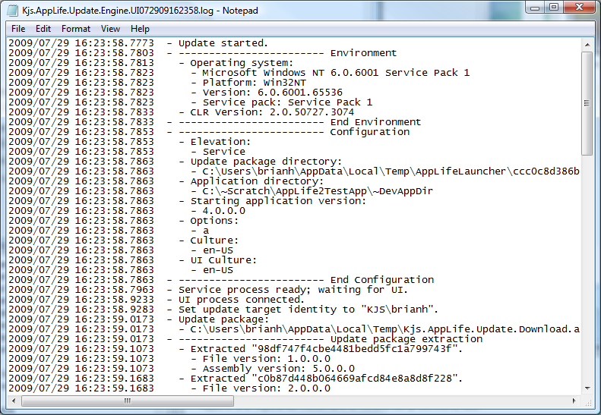
During an update, a log file is created that documents the actions that are performed. This log file is used to diagnose update execution errors. The log file is located in the current user’s local application data folder.
Windows XP:
C:\Documents and Settings\[user]\Local Settings\Application Data\Kjs.AppLife.Update

Vista:
C:\Users\[user]\AppData\Local\Kjs.AppLife.Update

Elevated Updates
Updates that use the AppLife Update Windows Service are executed by the Local System account. The Local Application Data folder for the Local System Account is located in the profile for the Local System Account. After the update completes, the log file is copied to the initiating users log location.

Windows XP:
C:\Documents and Settings\LocalService\Local Settings\Application Data\Kjs.AppLife.Update

Vista: C:\Windows\System32\config\systemprofile\AppData\Local\Kjs.AppLife.Update

Customize the Log Location
You can define your own logging location for your application by adding the appropriate registry entries described below. With a custom log location defined, your application will always log to the defined folder whether the service is used or not. If your custom logging folder doesn’t exist, AppLife Update will attempt to create it. If the folder can’t be created, or the current user does not have permissions to write there, the log will be written to the default AppLife Update logging location.

Defining your log location:
Add a registry key for your application ID under the HKLM\SOFTWARE\KineticJump\AppLifeUpdate\ApplicationSettings registry key and add a LogDirectory String value that contains the path to your log folder.
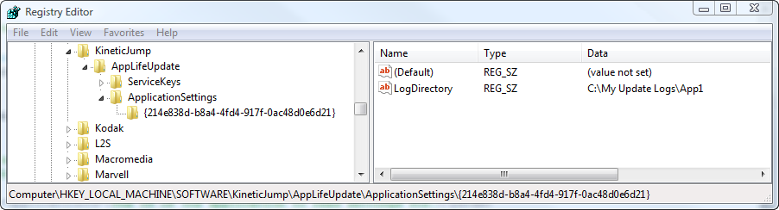

Disable Logging
Update execution logging can be disabled for a designated application. To disable logging, add a registry value:
HKLM\SOFTWARE\KineticJump\AppLifeUpdate\ApplicationSettings\ {ApplicationID}
DisableLogging (DWORD)
If this value is present with a value of 1, logging will be disabled for the designated application id.

Accessing Logs through the API
Using the AppLife Update Controller, you can programmatically access update history for your application. Update history includes:
- The initial version number being updated
- The version of the update package
- The start and end time of the update
- The update result
- The type of elevation used
- The log file path
- The summary text
- The custom data
Use this information for troubleshooting update issues and to provide access to update history for your users.

The Update Controller has a static method named GetUpdateHistory that will return a collection of LoggedUpdate classes. Please see AppLife Update API Reference from the help menu for more information.
<OBJECT id=hhctrl type="application/x-oleobject"
classid="clsid:adb880a6-d8ff-11cf-9377-00aa003b7a11"
codebase="hhctrl.ocx#Version=6,0,6001,18000"
width=100
height=100
>
<PARAM name="Command" value="ShortCut">
<PARAM name="Button" value="Text:AppLife Update API Reference">
<PARAM name="Item1" value=",..\API Help\Kjs.AppLife.Update.API.chm,">
</OBJECT>

64 Bit Operating Systems
The Windows XP and Windows Vista operating systems have 64 bit versions. Special consideration must be given when installing and updating software on 64 bit operating systems. These 64 bit operating systems have a 32 bit sub-system for compatibility with 32 bit software. AppLife Update provides update authors the ability to specifically target the 32-bit sub-system registry and file system. Update authors can also explicitly register 32 bit and 64 bit COM assemblies.

Applications built to execute in 64-bit mode will automatically integrate with the 64-bit system, and 32-bit applications will automatically interact with the 32-bit sub-system. Installers are not as straightforward and care must be taken to ensure applications operate as expected when installed on a 64-bit Windows operating system.

With AppLife Update, any action configured to target an x86 sub-system on 64-bit operating systems will also target the equivalent location on 32-bit operating systems.

Windows Presentation Foundation (WPF)
The AppLife Update Controller is completely compatible with the .Net Framework 3.5 and WPF applications. Though the built-in user interface forms that are in the Update Controller are Windows Forms based, they can still be shown from WPF applications. In addition, you can completely customize your user interface using WPF XAML, just as you can create custom winforms user interfaces.
Integration Points to consider with WPF applications
- The Update Controller is Disposable
The controller class is disposable and must be disposed when you are done using it. Placing a controller on a WinForms designer adds the control to the form container, and the container ensures that the controller is disposed when the form is closed. In WPF this won’t be the case.
If you intend to utilize the built-in Inter-process communications(IPC) of the update controller to coordinate the shutdown of multiple instances, then instantiate your controller and keep it instantiated throughout the lifetime of your main WPF Window. Ensure the control is disposed as the Window closes.
- Setting the Owning Form
To utilize the built-in user interface for updating, the Update Controller methods expect a IWin32Window class for the owner parameters. If you don’t set an owner, the dialogs that the Update Controller displays will not be properly positioned. You can easily wrap a WPF Window using this simple wrapper class, allowing you to pass the WPF Window to the Update Controller properties.
private class WindowWrapper : System.Windows.Forms.IWin32Window {
private System.Windows.Interop.WindowInteropHelper mHelper;
public WindowWrapper(Window window) {
if(window != null) {
mHelper = new System.Windows.Interop.WindowInteropHelper(window);
}
}
public IntPtr Handle {
get {
if(mHelper == null) {
return IntPtr.Zero;
} else {
return mHelper.Handle;
}
}
}
}
Example Usage:
mController.UpdateInteractive(new WindowWrapper(this));

The User Account Control (UAC)
On Windows 7 and Windows Vista, privileged users execute applications with a limited security token. When a privileged user attempts to perform an action that required higher privileges, they are prompted for confirmation ( Limited users are prompted for credentials). If your update package requires higher credentials to complete and have chosen not to deploy and use the AppLife Update Windows Service for elevation, you can utilize the UAC to attempt elevation.

The default behavior of the Update Controller is to initiate an update using the same privileges as the current user. You can set the Update Controller to utilize the UAC or the AppLife Update Windows Service for permissions elevation using the ElevationType property.

If you choose the UAC, the update is launched from an unknown publisher:
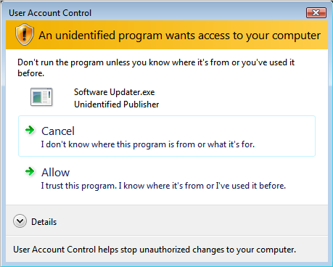

You can optionally code sign the launcher for your update project. The launcher is compiled by Make Update and cannot be used with any other project than the one that created it. Code signing the launcher allows you to identify your organization as the publisher of the update that your users will apply.
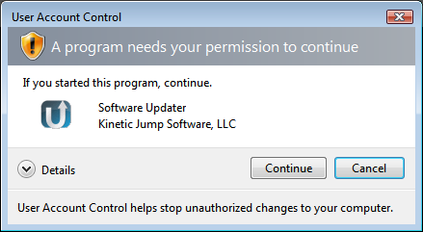

To code sign your launcher, choose the UAC Launcher menu item from the Tools menu.
- Using the dialog, you can optionally specify an icon for your launcher, then save the executable file to your file system. Keep track of the saved exe file as it is the only file that can be imported back into the update project.
- Code sign the saved executable using your organizations certificate. If you do not have a certificate, there are many vendors who can provide this.
www.verisign.com
www.thawte.com
- Import the code signed executable back into your AppLife Update project file.

Once imported, future updates will properly identify your organization as the publisher of the update.

Building Your Update

Initial Install
There are many ways to deploy your application. The most common method used is an MSI setup program, but just file copying is also a method (XCopy deploy). After your initial install, AppLife Update helps you maintain your deployed installation by providing the means to build and publish updates that your software downloads and applies.

Building an Update Package
The Make Update application is used to build update packages. Using Make Update, an update is created by adding Update Actions to the action list in your AppLife Update project. When you build an update, all of the actions in the action list are processed, and all of the new files and instructions defined in the action list are packaged up into an update package. This is a file names major.minor.build.revision.zip. The update package is compressed with gzip compression, but given the zip extension so that web servers won’t block serving them up.

To create an update, click the Create an Update… button.
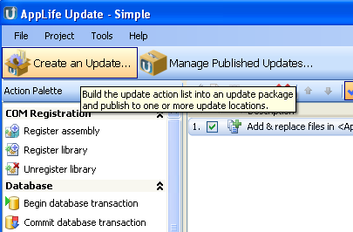

- Set the Update version of the new update.
Note: This value can be automatically set by referencing the assembly version or file version of a designated file. See Project Properties
- Define the previous versions that can successfully apply the new update.
- Write any summary text information that you would like the user to see. (This information is available from the Update Controller when the update is discovered).

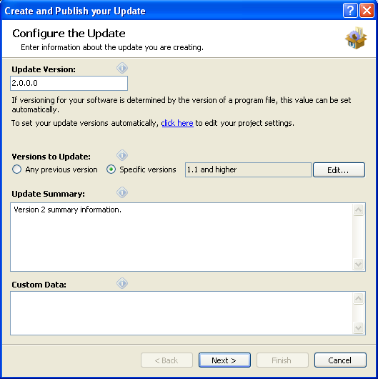

- Select one or more update locations to publish the new update to.
- If your publish location requires credentials, you can enter them here.

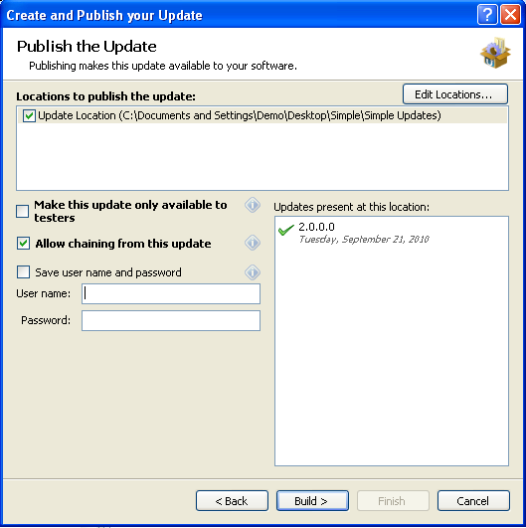

- Click the Build button to build and publish the new update.

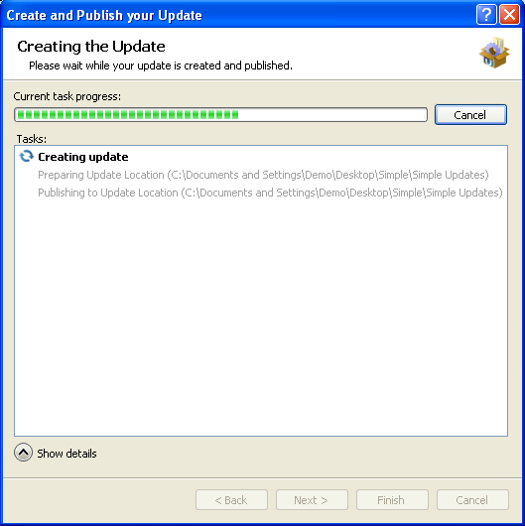

The AppLife Update Engine
When the Update Engine is executed on the client computer, the downloaded update package is parsed to determine the actions that should be executed on the client computer. The Update Engine performs the update in a three stage operation.
- Prepare
- Execute
- Cleanup
Each update action contained in the update package defines methods for each stage the engine executes, as well as a rollback method should an unexpected exception occur during the update process. The engine first iterates the action list, calling the Prepare method on each action. Within the prepare method, each action perform any preparatory and backup activity necessary. Backup activity is performed to facilitate rolling back the state of the client to its initial pre-update state.
Upon successful completion of the Prepare stage, the engine starts over and iterates each action calling the Execute method. Within this method the action performs the update steps. Any activity that must be completed for this update to be successful is performed in the Execute stage. When this stage is completed for all the actions in the update package, the client software is considered updated. Any unexpected exception that occurs prior to completing the Execute stage on all actions will cause the engine to enter into a Rollback process. If the Execute stage completes successfully, the engine moves on to the Cleanup stage.
The Cleanup stage is for removing any temporary files, logging custom activity, or tidying up behind the process. There are no activities critical to the success of the update occurring in this stage. If an unexpected exception occurs in this stage, the stage is aborted, but a complete rollback will not occur. In this event the software is considered successfully updated, but there might be files left in the user’s temporary directory.
In the event of an exception that causes a rollback, the engine starts at the current action and iterates in the reverse order. Each action executes its defined rollback activity. When the rollback process completes, the client software should be back to the same state that existed before executing the update.
Each update package is self-contained and includes the update engine.

Target Versions
A target version is a software version that is eligible to apply a specific published update. When an update is created, its version number is defined along with a list of target versions that can apply the update.
For example, if you are building an update to version 2.0.0.0 of your software, and that update is designed to update version 1.0.0.0 of your software to version 2.0.0.0, then the target list for building the 2.0.0.0 update would include 1.0.0.0.
Special Targets
Many applications have targets that overlap with each update. To simplify these scenarios, there are two special target values that you can use when building updates.

All Targets
If any previous version of your software can be updated to the current published version, then an <all> entry can be placed into the Target List. This is the default entry on a new project. When the Target List for a published update includes the “<all>” entry, then any software version that is lower than the current publish version can be updated by the update.

Greater Than or Equal To
When a new update can be applied to all previous versions that are greater than or equal to an earlier version, then the target can be defined as such. A target list value like this can be applied to any software version that is larger than or equal to the target version and smaller than the current publish version number.

Update Summary Text
For each published update, you can provide a plain text summary of what the update accomplishes for your software. This summary should only contain information about the changes made between this update and the previous version. This text is displayed on the Check for Updates form, and is available to you through the Update Controller API, should you choose to implement a custom updating experience.
When an update will skip one or more versions, the Update Summary text displayed during the update process will include all update summaries between the current version and the update version.

No Update Summary Text
This is text to be displayed to the user when no updates are available. This text is set on an update location scope and is set within the project properties. This text is available through the Update Controller API.
The standard Check for Updates form displays this text when no update is found. By default, the value is empty.

Publishing a Test Update
An update can be published for limited availability to testers with a special Test attribute. For a client to discover a test update there must be a specific key in the application app.config file. To enable a client to retrieve test updates, add the following to the host application’s app.config file.

<configuration>
<appSettings>
<add key="Kjs.AppLife.Update.Tester" value="true"/>
</appSettings>
</configuration>

Clearing the test attribute
An update that was published as a test update can be switched to a normal update by managing the location that the update was published to. Select the update from the list of updates, and uncheck the Make this update only available to testers checkbox. Publish the changes and the update will be available to all clients.

Note: You can also switch a normal update to a test update.

Proxy Settings
AppLife Make Update will automatically detect proxy settings in order to publish an update. If you are behind a proxy server and automatic proxy detection fails in your environment, you can set the proxy settings manually from the options form.

Note: Ftp publishing through an http proxy server is not supported. In this scenario, you must use http publishing or bypass your proxy server for ftp.

Managing Published Updates
Project update locations can be managed through AppLife Make Update. To manage an update location, click the Manage Published Updates… button and select the location that you wish to manage.
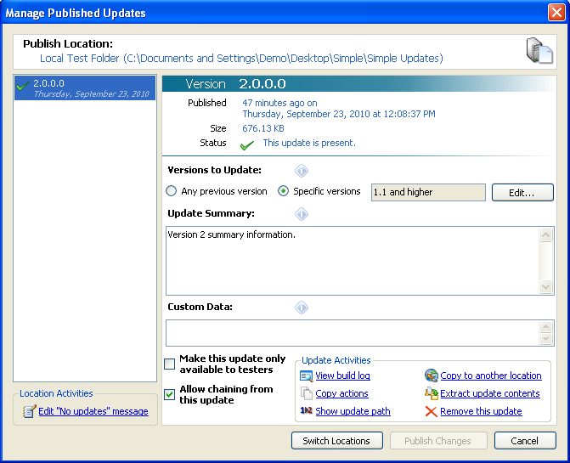
From the location management dialog, all of the updates published to the location can be viewed, and information about each update can be modified and published. The activities that can be performed from this dialog include:
- Removing an update
An update can be removed by selecting the update and clicking Remove this update from the activities list.
- Change targets
The target list of a published update can be modified.
- Modify summary text
The summary text that describes a published update can be modified.
- Release a test update
Each update can be defined as a test update or normal update, affecting which clients can discover the update. To release a test update, uncheck the Make this update only available to testers checkbox.
- Modify Custom Data
The custom data for a specific update can be modified.
- Copy an update to another location
A selected update can be copied to another update location.
- Extract an update’s contents
A selected update can be extracted to a local folder.
- View the build log
The build log created as the update was built can be viewed.
- Copy update actions to the clipboard
The update actions are copied to the clipboard, configured as they were when the update was built. The actions can then be pasted into another action list.

Publishing Changes
Any changes to an update will enable the Publish Changes button. Changes must be published. Any changes not published will be lost when the dialog is closed. Once published, clients will discover the changes when they check for updates.

Comparing two Update Locations
Two update locations can be compared. Comparing update locations lets you see at a glance any missing or different updates between them. To compare two locations, click to Manage Published Updates… then check to compare locations, and select the location that you wish to compare.
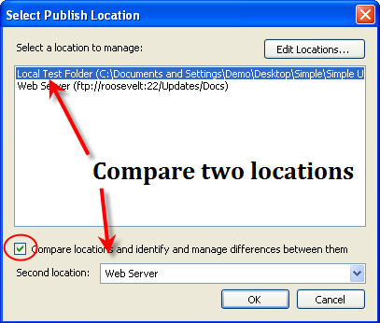

The location selected in the list is Location A, and the location in the combo box is Location B.

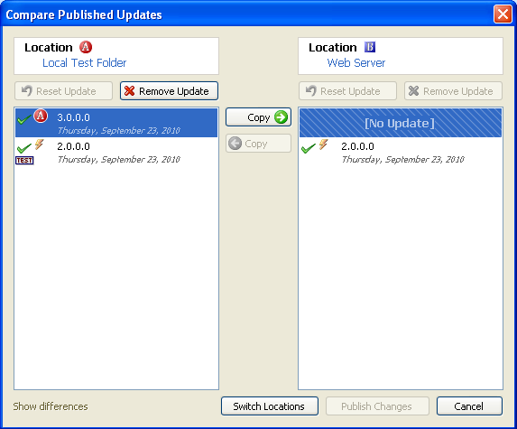

The comparison dialog shows the updates at the two selected locations, along with adornments indicating information about the updates. In the example above, you can see that location B does not contain an update for version 3.0.0.0. In addition, there is a difference in version 2.0.0.0. Updates can be copied from one location to another using the Copy left and Copy right buttons. In addition, when differences are present in a specific update version, you can see the differences by selecting the update and clicking on the Show differences link.

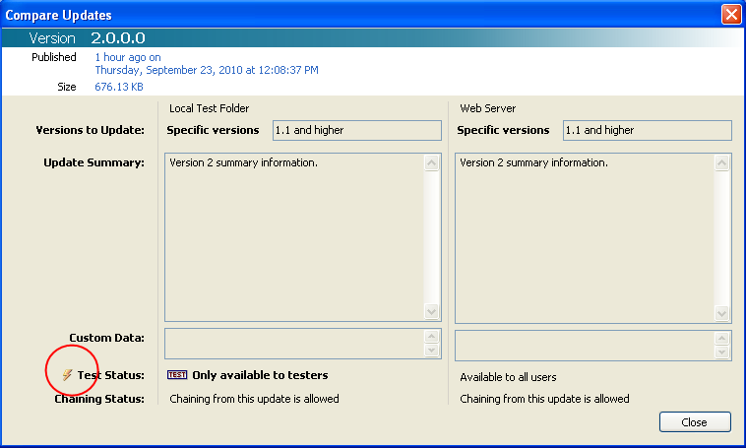

Copying update 3.0.0.0 right, and update 2.0.0.0 left results in update 3.0.0.0 being published to location B, and the test status being cleared for update 2.0.0.0 in location A. Publishing these changes results in the two update locations becoming identical.

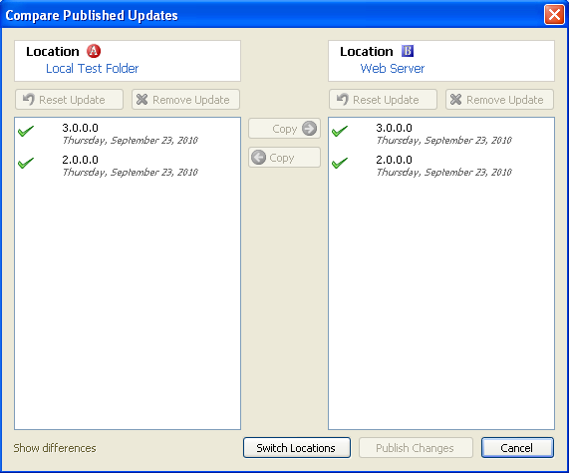

The AppLife Update Windows Service
The AppLife Update Windows Service allows limited users to securely apply updates that you publish under the security context of the local system account. This provides the ability to maintain your application on deployed clients without administrative support.
To use the AppLife Update Windows service for elevation, you must set the ElevationType property of the update controller AppLifeUpdateService. You must also deploy the service with your application and ensure proper registration. Deploying the service and registering your application to use it does require administrative privileges. Once deployed, your updates can be applied by limited users.

Service Registration
To utilize the AppLife Update Windows Service, your application must be registered with the service. The service will validate any update package that is applied with a public key that resides in the system registry.
Registration adds an entry for your application in the system registry. The service will look for this entry when your application attempts to use it to apply an update. Entries are added to:

HKLM(x86)\SOFTWARE\KineticJump\AppLifeUpdate\ServiceKeys\appkey

Your appkey must include two values:
Path – The complete path to the host executable. This is your application.
Public Key – The public key from the application Make Update project (aup).
An application path should only be registered once. If a single host application applies updates from multiple AppLife Update projects, all projects must share the same key pair. (See importing key pairs).
To manually register your application, add the necessary registry keys. When the AppLife Update Windows Service is deployed using the merge module included in the AppLife Update application directory, registration is accomplished by setting the two merge module properties.
Applications that attempt to use the AppLife Update service and are not registered will fail with an update package failed validation message.

Viewing your Project File Public Key
Open your AppLife Update (aup) project in AppLife Make Update. Open the project settings dialog from the Project menu. On the security tab, the public key is displayed.
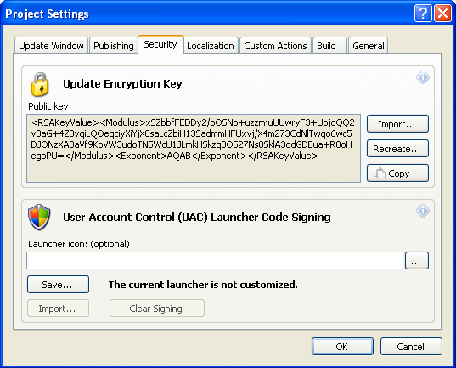

The AppLife Update Service Registration Utility
To register applications with the service during development, you can use the AppLife Update Service Registration utility. This utility can be launched from the Make Update Tools menu, as well as from the WinForms and WPF Update Control designers.
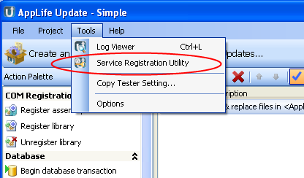

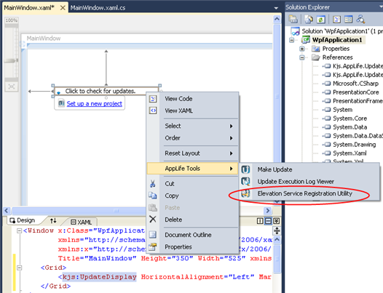

With the service registration utility, you can easily add registrations for applications under development on the development system.
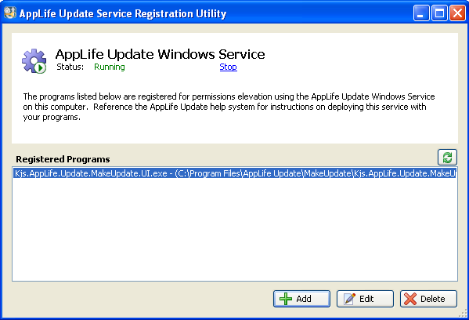

Adding a registration…

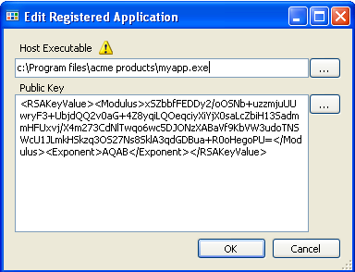

Deploying the AppLife Update Windows Service
If you have configured your application to utilize the AppLife Update Windows Service, you will utilize the service merge module for deployment. Using the merge module ensures proper reference counting for uninstalling. The service is a shared resource and a single instance of the service is installed for all AppLife Update enabled applications on the system. The service merge module also registers your application for use with the service.
The AppLife Update Windows Service merge module is located in AppLife AppDir\UpdateService\AppLifeUpdateService.msm.
To use the Update Service merge module, add it to your Windows Installer setup. The merge module has two configuration properties that must be set.
Path
Set this value to the path of the application executable that hosts the Update Controller. You can use windows installer database properties to identify the location of your executable. A common value for this property is [TARGETDIR]yourapp.exe
Public Key
Set this to the public key of your application project. This is the same value as the PublicKeyToken property of the Update Controller. You can also view your project public key from the project settings dialog.

Note: The merge module adds a requirement for administrative permissions to execute your Windows Installer.

Deploying an AppLife Update Enabled Application
Update Controller
To deploy an AppLife Update enabled application, ship the Kjs.AppLife.Update.Controller.dll assembly with your application. The controller assembly should be located in your application directory.

Using Localized Resource (de, es, fr, it, ja, ru, zh-CHT + community translations)
AppLife Update ships with localized resources. The localized satellite assemblies are located in the InstallDir/PublicAssemblies/Localized Resources directory. To include localized controller resources, move the specific locales from this folder into the folder that contains the Kjs.AppLife.Update.Controller.dll.

WPF Controls
If you are using the WPF controls, you must ship the Kjs.AppLife.Update.Wpf.dll assembly along with the update controller assembly.

The AppLife Update Windows Service
If you have configured your application to utilize the AppLife Update Windows Service, you must ship the Windows Service with your application. See deploying the windows service for more information.

The update engine and update actions are not deployed with your application. They are included in every update package. Your application extracts the engine from the downloaded update package as updates are applied.

Update Options

Controlled Rollout
When a new update is made available to a large audience of clients, the availability of the update can be limited for a specified period of time. By controlling the initial rollout, you can avoid bandwidth and server loading issues that might occur.
A controlled rollout limits the number of clients that can discover the update for a specified time period. This time period is set on the Update Controller ControlledRolloutHours.
When the hosting application is launched, a random number between 0 and the number of controlled hours is generated. This number represents the hour after which a new update was published, that this client can receive the update. Statistically, the clients should be evenly distributed across the designated controlled rollout period.
When the Update Controller checks for an available update, the universal time difference between now and when the update was published is calculated. If the time difference is in the Controlled Rollout window, the randomly generated number is checked to see if it is less than the time difference. If so, the update is available, otherwise it is not.
The Update Controller property EnableControlledRollout must be set to true to enable controlled rollouts. The default value is false.

Customized Forms
AppLife Update contains a default Check for Updates form and an Update Download Status form. These forms are designed to be aesthetically appealing though generic, allowing for integration into a wide variety of applications. If our default forms do not adequately match your applications visual theme, you can implement your own forms. See the Custom Forms Quick Start for guidance.

Check for Update Form
To implement your own Check for Updates form, you will call a check for update method on the Update Controller and then interrogate the CurrentUpdate property for information about any discovered updates.
There is both a synchronous and asynchronous method to check for updates. The synchronous CheckForUpdates method is a blocking method and returns a boolean value indicating whether an update was found or not. The CheckForUpdatesAsync method is a non-blocking call. You can handle the CheckForUpdateCompleted event to be informed when the asynchronous call completes. The event argument contains a property that indicates whether or not an update was discovered.
With either Check for Update call, if an update is found, information about the update can be utilized by looking at the CurrentUpdate property. If no update is found, the CurrentUpdate property is empty or null.
Note: Please reference the Update Controller API documentation for more information on these methods. Also, please reference the Custom Forms Quick Start project for an example of using custom forms.

Download Update Form
If the standard update download form does not match your application, you can implement your own download form. You do not need to implement a custom download form just because a custom Check for Updates form was implemented. To show the standard download form after utilizing a custom Check for Updates form, you can call the ShowDownloadUpdateDialog method.
To implement a custom download form, you call a download method on the Update Controller. There is both a synchronous and asynchronous download method. When using the asynchronous method, you can subscribe to a progress event and a completion event. Both event handlers are guaranteed to be executed on the same thread that started the download. The progress event handler has an event argument that provides progress information.
After an update is downloaded by using the ShowDownloadUpdateDialog or a call to a download method, you must call ApplyUpdate on the Update Controller to initiate the update process.
Note: Please reference the Update Controller API documentation for more information on these methods. Also, please reference the Custom Forms Quick Start project for an example of using custom forms.

AppLife Update Components

Update Controller
The Update Controller is a .Net component that can be added to any .Net 2.0 application. The Update Controller exposes properties and methods that you can use to check a network location for any available updates, download an update, and initiate the process of updating the software. The Update Controller can be distributed with your application free of any royalties.

Update Service
The Update Service is a Windows Service that allows for the execution of an update action list with elevated privileges.

Make Update
Make Update is a windows forms application that allows a user to define an update, build an update package, and publish the update package to a network resource. Make Update also allows for the modification of information about available updates.

Make Update Console Application
The AppLifeUpdateCmd.exe console application allows for building and publishing update project files. The console application enables AppLife Update publishing functionality to be integrated into your automated build and packaging processes. See Automating Updates for more information.

